# Frost Retro High-Tops

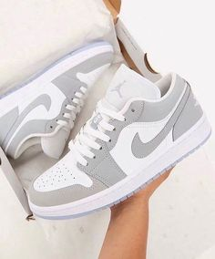

Product Details:

Color Combination: The Jordan Frost Retro High-Tops exhibit a clean and icy color palette featuring soft lavender gray and subtle gray.

Material: Constructed from premium synthetic leather and durable textile materials, ensuring both style and durability.

Sole: Designed with a cushioned midsole for optimal comfort and a durable rubber outsole for traction and stability.

Closure: Secure lace-up closure system for a snug and adjustable fit.

Branding: Iconic Jumpman logo detailing prominently displayed on the tongue and side panels, signifying the shoe's authentic Jordan lineage.

Comfort: Padded collar and cushioned insole provide all-day comfort and support, perfect for extended wear.

Style: The Jordan Frost Retro High-Tops blend classic design elements with modern aesthetics, offering a timeless yet contemporary look.

Occasion: Versatile enough for various occasions, from casual outings to more athletic activities.

Versatility: Pair with jeans, joggers, or even sportswear for a stylish and athletic-inspired ensemble that's sure to turn heads.